Anemia: Sickle cell disease
Sickle cell disease (SCD), also simply called sickle cell, is a group of hemoglobin-related blood disorders that are typically inherited. The most common type is known as sickle cell anemia. Sickle cell anemia results in an abnormality in the oxygen-carrying protein haemoglobin found in red blood cells. This leads to the red blood cells adopting an abnormal sickle-like shape under certain circumstances; with this shape, they cause blockages.
A number of health problems may develop, such as attacks of pain (known as a sickle cell crisis) in joints, anemia, swelling in the hands and feet, bacterial infections, dizziness etc. The probability of severe symptoms, including long-term pain, increases with age. Without treatment, people with SCD rarely reach adulthood but with good healthcare, median life expectancy is between 58 and 66 years. The liver, heart, kidneys, gallbladder, eyes, bones, and joints can be damaged from the abnormal functions of the sickle cells and their inability to effectively flow through the small blood vessels. Sickle cell disease occurs when a person inherits two abnormal copies of the β-globin gene that makes haemoglobin, one from each parent. Several subtypes exist, depending on the exact mutation in each haemoglobin gene. An attack can be set off by temperature changes, stress, dehydration, and high altitude. A person with a single abnormal copy does not usually have symptoms and is said to have sickle cell trait and are referred to as carriers.
The care of people with sickle cell disease may include infection prevention with vaccination and antibiotics, high fluid intake, folic acid supplementation, and pain medication. Other measures may include blood transfusion and the medication hydroxycarbamide (hydroxyurea). Recently, new gene therapies were approved involving the genetic modification and replacement of blood forming stem cells in the bone marrow.

First events
When SCD presents within the first year of life, the most common problem is an episode of pain and swelling in the child's hands and feet, known as dactylitis or "hand-foot syndrome." Pallor, jaundice, and fatigue can also be early signs due to anaemia resulting from sickle cell disease. In children older than 2 years, the most common initial presentation is a painful episode of a generalized or variable nature, while a slightly less common presentation involves acute chest pain. Dactylitis is rare or almost never occurs in children over the age of 2.
Vaso-occlusive crisis
Also termed "sickle cell crisis" or "sickling crisis", the vaso-occlusive crisis (VOC) manifests principally as extreme pain, most often affecting the chest, back, legs and/or arms. The underlying cause is sickle-shaped red blood cells that obstruct capillaries and restrict blood flow to an organ, resulting in ischaemia, pain, necrosis, and often organ damage. The frequency, severity, and duration of these crises vary considerably. Milder crises can be managed with nonsteroidal anti-inflammatory drugs. For more severe crises, patients may require inpatient management for intravenous opioids. Vaso-occlusive crisis involving organs such as the penis or lungs are considered an emergency and treated with red blood cell transfusions. A VOC can be triggered by anything which causes blood vessels to constrict; this includes physical or mental stress, cold, and dehydration.
How sickle cell causes anemia.
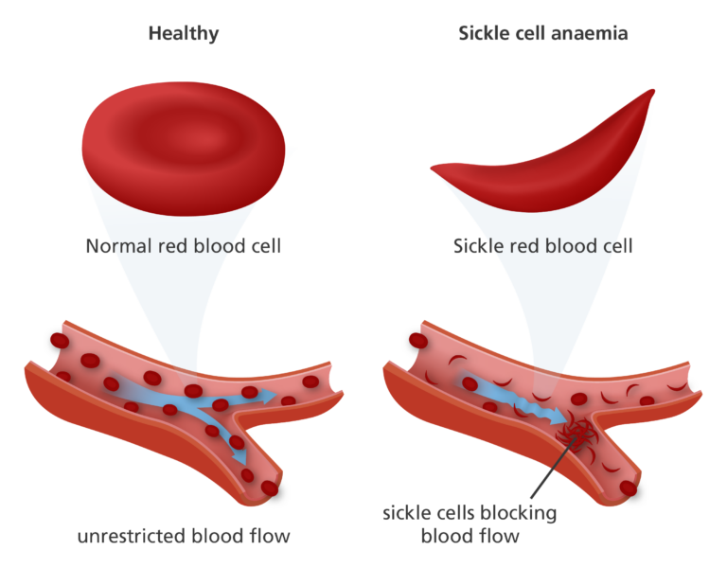
The figure shows the round shape of rbc which is the healthy cells and the other is sickle shaped which is the unhealthy one.

Sickle cell disease causes anemia because the abnormally shaped sickle cells have a shorter lifespan than normal red blood cells and are more prone to destruction, leading to a shortage of red blood cells and a reduced ability to carry oxygen. This, in turn, causes anemia, which manifests in symptoms like fatigue and shortness of breath. So basically, the steps below involves how anemia is caused:

1. Abnormal Hemoglobin:
- In sickle cell disease, the red blood cells contain a protein called hemoglobin that is abnormal due to a genetic mutation.
- This abnormal hemoglobin causes the red blood cells to become sickle-shaped instead of the normal, round shape.
2. Reduced Lifespan:
- Healthy red blood cells typically live for about 120 days, but sickle cells only survive for about 10-20 days.
- This shorter lifespan means that the body produces fewer red blood cells to replace the sickled cells that are destroyed.
3. Anemia:
- The shortage of red blood cells due to their premature destruction results in anemia.
- Anemia is a condition where the body doesn't have enough healthy red blood cells to carry enough oxygen to the tissues.

Complications
Sickle cell anaemia can lead to various complications including:
- Increased risk of severe bacterial infections is due to loss of functioning spleen tissue. These infections are typically caused by bacteria such as Streptococcus pneumoniae and Haemophilus influenzae. Daily penicillin prophylaxis is the most commonly used treatment during childhood, with some haematologists continuing treatment indefinitely. Patients benefit from routine vaccination for S. pneumoniae.
- Stroke can result from blockage of blood vessels in the brain, causing numbness, confusion, or weakness which may be long lasting. Silent stroke causes no immediate symptoms, but is associated with damage to the brain. Silent stroke is probably five times as common as symptomatic stroke. About 10–15% of children with SCD have strokes, with silent strokes predominating in the younger patients.
- Avascular necrosis (aseptic bone necrosis) of the hip and other major joints may occur as a result of ischaemia.
- Pulmonary hypertension (increased pressure on the pulmonary artery) can lead to strain on the right ventricle and a risk of heart failure; typical symptoms are shortness of breath, decreased exercise tolerance, and episodes of syncope.[48] 21% of children and 30% of adults have evidence of pulmonary hypertension when tested; this is associated with reduced walking distance and increased mortality.
- Cardiomyopathy and left ventricular diastolic dysfunction caused by fibrosis or scarring of cardiac tissues. This also contributes to pulmonary hypertension, decreased exercise capacity, and arrhythmias.

Pathophysiology
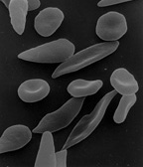

Scanning electron micrograph showing a mixture of red blood cells, some with round normal morphology, some with mild sickling showing elongation and bending.
Under conditions of low oxygen concentration, HBS polymerises to form long strands within the red blood cell (RBC). These strands distort the shape of the cell and after a few seconds cause it to adopt an abnormal, inflexible sickle-like shape. This process reverses when oxygen concentration is raised and the cells resume their normal biconcave disc shape. If sickling takes place in the venous system, after blood has passed through the capillaries, it has no effect on the organs and the RBCs can unsickle when they become oxygenated in the lungs. Repeated switching between sickle and normal shapes damages the membrane of the RBC so that it eventually becomes permanently sickled.
Normal red blood cells are quite elastic and have a biconcave disc shape, which allows the cells to deform to pass through capillaries. In sickle cell disease, low oxygen tension promotes red blood cell sickling and repeated episodes of sickling damage the cell membrane and decrease the cell's elasticity. These cells fail to return to normal shape when normal oxygen tension is restored. As a consequence, these rigid blood cells are unable to deform as they pass through narrow capillaries, leading to vessel occlusion and ischaemia.
Cells which have become sickled are detected as they pass through the spleen and are destroyed. In young children with SCD, the accumulation of sickled cells in the spleen can result in splenic sequestration crisis. In this, the spleen becomes engorged with blood, depriving the general circulation of blood cells and leading to severe anemia. The spleen initially becomes noticeably swollen but the lack of a healthy blood flow through the organ culminates in scarring of the spleen tissues and eventually death of the organ, generally before the age of 5 years.
The actual anaemia of the illness is caused by haemolysis, the destruction of the red cells, because of their shape. Although the bone marrow attempts to compensate by creating new red cells, it does not match the rate of destruction. Healthy red blood cells typically function for 90–120 days, but sickled cells only last 10–20 days.
The rapid breakdown of RBC's in SCD results in the release of free heme into the bloodstream exceeding the capacity of the body's protective mechanisms. Although heme is an essential component of hemoglobin, it is also a potent oxidative molecule.

Diagnosis

Prenatal and newborn screening
Checking for SCD begins during pregnancy, with a prenatal screening questionnaire which includes, among other things, a consideration of health issues in the child's parents and close relatives. During pregnancy, genetic testing can be done on either a blood sample from the fetus or a sample of amniotic fluid. During the first trimester of pregnancy, chorionic villus sampling (CVS) is also a technique used for SCD prenatal diagnosis. A routine heel prick test, in which a small sample of blood is collected a few days after birth, is used to check conclusively for SCD as well as other inherited conditions.

Tests
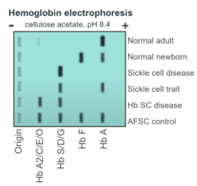

A schematic of hemoglobin electrophoresis, showing the banding which is typical of various types of hemoglobin. Note that sickle cell disease (SCD) gives a single, bold band whereas sickle cell trait gives two slightly fainter bands.
Where SCD is suspected, a number of tests can be used. Often a simpler, cheaper test is applied first with a more complex test such as DNA analysis used to confirm a positive result.
Two tests which are specific for SCD include:
- Blood smear: a thin layer of blood smeared on a glass microscope slide and then stained in such a way as to allow the various blood cells to be examined microscopically. This technique can be used to visually detect sickled cells, however it does not detect sickle carriers.
- A solubility test relies on the fact that HbS is less soluble than normal hemoglobin (HbA); it is highly reliable but does not distinguish between full SCD and carrier status.
- NOTE: the disadvantage or limitation of the two tests for SCD.

